Vth Semester B. Tech Data Science & Engineering
DSE 3141 Deep Learning Lab - Mini Project
Generative Adversarial Networks for Brain Tumour Detection via Anomaly Detection
by
Rishik Reddy Bandi
220968300

1. Problem Statement

The early detection of brain tumors is critical for improving patient outcomes and enhancing treatment efficacy. Traditional diagnostic methods rely heavily on the manual examination of MRI scans by expert radiologists, a process that is time-consuming and prone to variability due to human fatigue and subjectivity. Moreover, in many regions, the shortage of skilled radiologists creates a bottleneck, delaying diagnosis and treatment.

This project aims to address these challenges by leveraging the power of Generative Adversarial Networks (GANs) to automate the detection process. GANs learn the distribution of healthy brain patterns, enabling the system to identify anomalous regions that may indicate tumour presence. By training the model on a dataset of healthy brain MRI scans, the system learns to recognize normal anatomical structures. When presented with new images, it can highlight deviations from these learned patterns, potentially indicating the presence of tumours. This approach not only accelerates the detection process but also provides a reliable, automated tool to support medical professionals, especially in resource-constrained environments where access to expert radiologists is limited.

2. Meta Data of the Dataset
Dataset: Brain Tumour MRI Dataset
The dataset was taken from Kaggle which was uploaded by Masoud Nickparvar. The dataset is a curated combination of three sources (Br35H, Figshare, SARTAJ), containing 7,023 images, categorized into four classes.
Classes:
- Glioma: A type of tumour that occurs in the brain and spinal cord.
- Meningioma: A tumour that forms on membranes covering the brain and spinal cord.
- Pituitary: A tumour that occurs in the pituitary gland.
- No Tumour: Images of normal brains without any tumour
Image Count:
- Glioma: 2,500
- Meningioma: 1,000
- No Tumour: 2,200
- Pituitary: 1,323
Image Format:
- Grayscale MRI images in .jpg format.
Split:
- The dataset is split into training set (5,406 images) and testing test (1269 images) respectively.
Dimensions:
- Images vary in dimension (analysed below).

3. Exploratory Data Analysis (EDA)

3.1 Image Dimension Analysis
- The histograms suggest that the images in the dataset are primarily square shaped with a side length of approximately 500 pixels. There is some variation in height, but most images are within a certain range around 600 pixels.
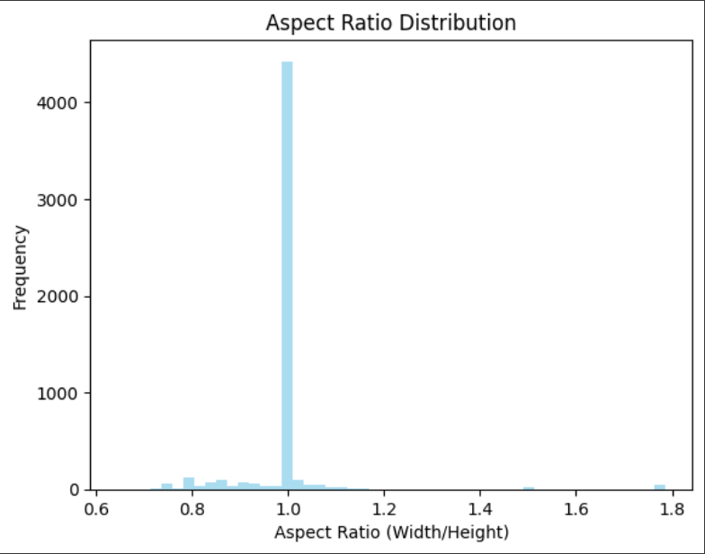
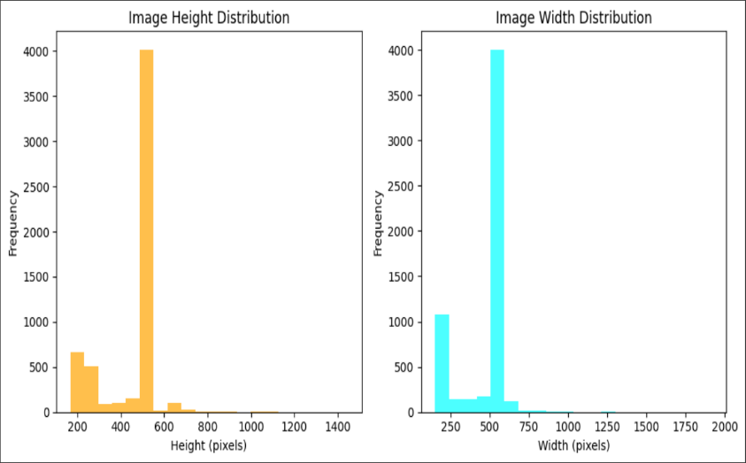

  - Classes Distribution
- An analysis of the class distribution revealed imbalances in the dataset.

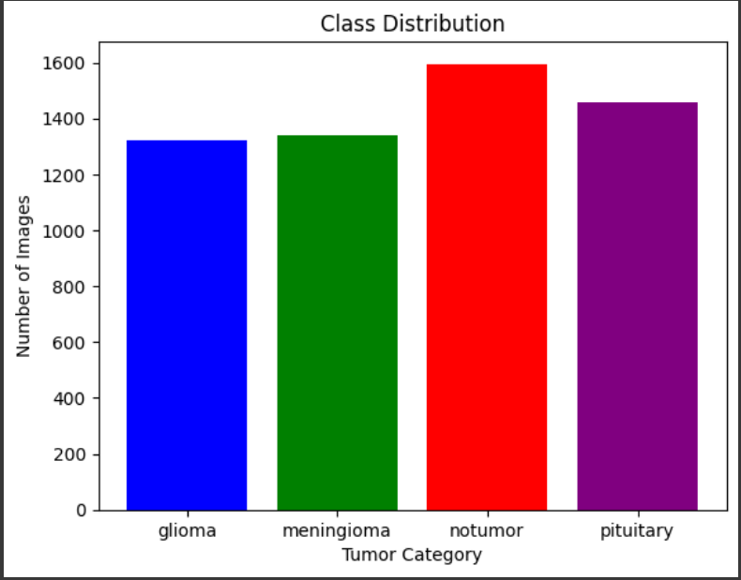
3.3 Pixel Intensity Distribution
- Analysis of pixel intensity distributions helps understand the range and variability of pixel values across different image categories.
- Histograms of pixel intensities for each category were plotted to visualize the distribution patterns. Significant differences in intensity distributions were observed among categories, providing insights into image characteristics.
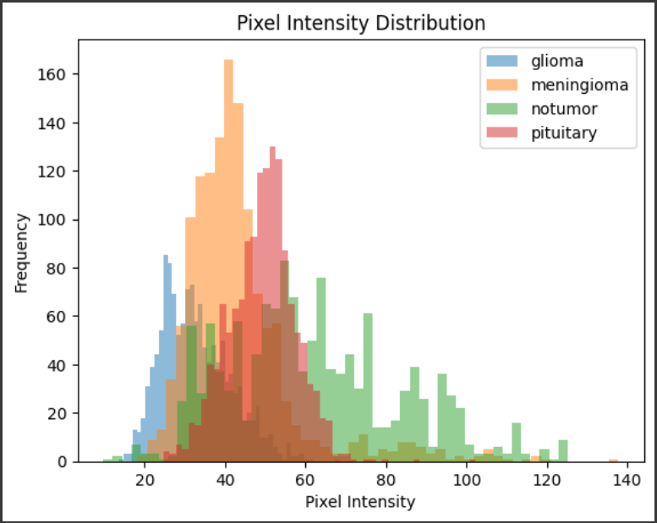

3.4 Removing Duplicate Images
- Duplicate images add bias to the model, it is crucial to remove them to avoid to ensure better accuracies.
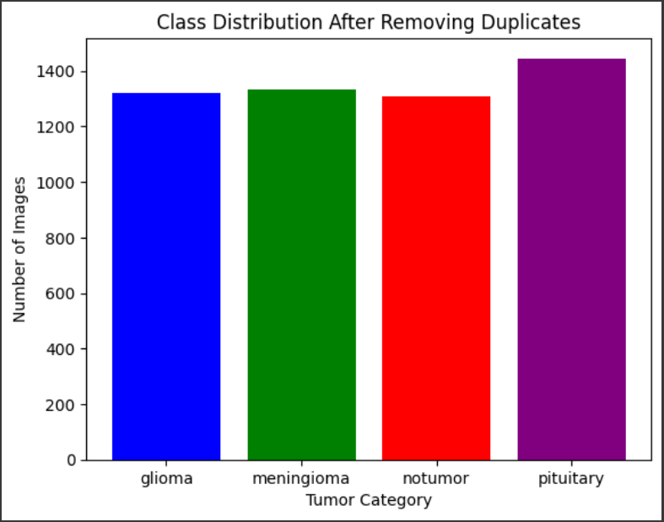
3.5 Sample Image from Each Class
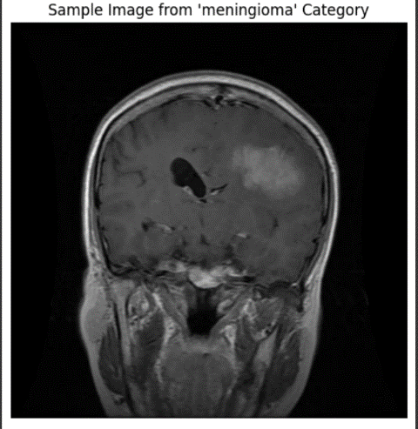
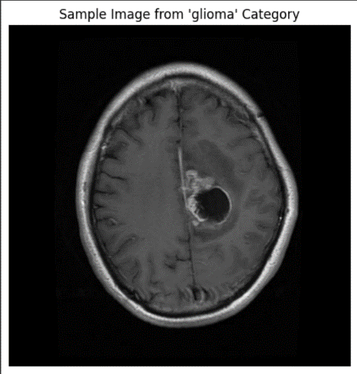

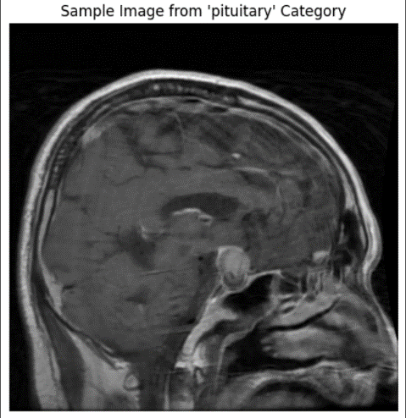
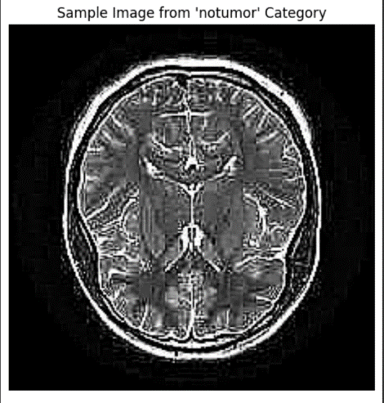

4. Preprocessing Pipeline

Image Resizing
- Method and Implementation: Standardized image dimensions to 224x224 pixels to ensure uniform input size for the model.
Data Augmentation
- Techniques and Benefits: Applied transformations such as rotation, flipping, zooming, and brightness adjustments to enhance dataset diversity and improve model robustness.
Normalization
- Pixel Intensity Scaling: Normalized pixel values to a range of 0 to 1 by dividing by 255 to standardize the input data.
Label Encoding
- Conversion of Categorical Labels: Converted categorical labels (glioma, meningioma, no tumour, pituitary) into numerical format for model training.

5. Performance Metrics
For anomaly detection using GANs, the following metrics can be used:
- Reconstruction Error: Measures the difference between the original image and the generated (reconstructed) image.
- Discriminator Score: In a GAN, the discriminator learns to distinguish between real and anomalous images. The discriminator's output score can be used to identify anomalies.
- Accuracy: Fraction of correctly classified tumour/non-tumour cases.
- Precision, Recall, F1-Score: Especially important for detecting the minority class (tumours).
- AUC-ROC Curve: Useful for visualizing the model’s performance in distinguishing between classes.

6. Project Objectives
- The primary objective of this project is to implement a Generative Adversarial Network (GAN) model to detect anomalies in brain MRI images, focusing on identifying brain tumours or other abnormal conditions. This can used to identify any abnormalities at an early stage.
- Deploying the model on web-based platform to ensure accessibility.
- Other objectives include creating multiple models to identify the best performing one, use of unsupervised data to create a model which will be more flexible for anomaly detection and compare these results with the supervised learning model.

7. Literature Review on Models

7.1 Overview
To detect anomalies in MRI brain scans, various models have been explored in medical imaging and tumour detection. This section reviews several models that are applicable to the project, including traditional supervised learning models and unsupervised learning approaches like GANs.

7.2 Review of Models
7.2.1 Convolutional Neural Networks (CNNs)
CNNs have shown success in medical image analysis, particularly in classification tasks. Their ability to learn spatial hierarchies from images makes them a strong choice for detecting brain tumours.
- Pros: High accuracy for image classification, easy to implement.
- Cons: Limited capability in anomaly detection if not trained explicitly on healthy brain data.

7.2.2 U-Net (Fully Convolutional Network for Segmentation)
U-Net is designed for image segmentation, making it useful in identifying and segmenting tumour regions in brain scans.
- Pros: Strong performance in medical image segmentation.
- Cons: Requires labelled segmentation data, which might not be available.

7.2.3 Variational Autoencoders (VAEs)
VAEs are unsupervised learning models that encode images into latent representations and then reconstruct them. By comparing the reconstruction with the original image, anomalies can be detected.
- Pros: Effective for unsupervised anomaly detection.
- Cons: Reconstruction quality might be low compared to GANs.

7.2.4 Generative Adversarial Networks (GANs)
GANs are useful for generating new data and detecting anomalies. The generator learns to produce realistic MRI images, while the discriminator distinguishes between generated and real images.
- Pros: Powerful for anomaly detection, does not require labelled data.
- Cons: Training can be unstable; prone to mode collapse.

7.2.5 ResNet (Residual Networks)
ResNet is a popular deep learning model for image classification, with deep layers and residual connections to avoid vanishing gradients.
- Pros: High accuracy, suitable for large-scale image datasets.
- Cons: Can be overkill for anomaly detection in small datasets.

8. Pros and Cons of Each Model

Model Pros Cons
CNN High accuracy, easy implementation Poor for unsupervised anomaly detection
U-Net Excellent for segmentation Requires labelled segmentation data
VAE Effective in unsupervised settings Lower reconstruction quality
GAN Best for unsupervised anomaly detection Unstable training, mode collapse risks
ResNet Very deep and accurate Computationally expensive, may overfit

9. Shortlisted Models for Implementation
Based on the literature review and the project's goal of anomaly detection, the following models have been shortlisted for implementation:
- CNN (Baseline): A simple CNN to classify images into different categories.
- ResNet: To be tested as a high-performance classification model for tumour detection.
- GAN with different Classifiers: To perform anomaly detection by generating healthy brain MRI images, identifying differences and classifying using a classifier (CNN, ResNet and KMeans).

10. Baseline Model

Given that the dataset involves spatial image data, a Convolutional Neural Network (CNN) has been selected as the baseline model. CNNs are effective for image classification and will provide a starting point for comparison with more advanced models like GANs.

11.Defining the Working End-to-End Pipeline
After the model selection phase, I designed and implemented a comprehensive end-to-end pipeline for brain tumour detection. This pipeline encapsulates the entire workflow from data ingestion to final model evaluation.

11.1 Pipeline Overview:
1. Data Preprocessing
- Image resizing to 256x256 pixels
- Grayscale conversion
- Normalization to [0,1] range
2. Model Architecture
GAN Component:
- Generator for image reconstruction
- Discriminator for feature extraction
- Anomaly scoring mechanism
Classifier Components:
- Preprocessing based on classifier
- Classifier Model
3. Training Process
- Two-phase training:
- GAN pre-training for anomaly detection
- Classifier fine-tuning for classification
- Data augmentation
4. Evaluation Pipeline
- Image preprocessing
- Hybrid prediction combining:
- GAN-based anomaly detection
- Classification
- Post-processing and decision making

Goals and Metrics
- Overall accuracy > 85%, with high ‘notumor’ accuracy and less false positive, negative (<5%) rates
- High F1-Scores as its medical imaging

12. Performance Optimization and Hyperparameter Tuning
Hyperparameters were scheduled to change whenever performance was reducing or stagnating
Optimization Parameters
- Learning Rates
- Batch Sizes
- Layers
- Activation Functions
- Dropout layers
- Early Stopping
- Epochs
- Thresholds for Anomaly Detection

13. Deployment
The model is deployed on the Hugging Face platform, providing an accessible and scalable environment for sharing the model.
A user-friendly interface was developed for easy interaction with the model using streamlit. This interface allows users to upload MRI images for classification and anomaly detection. The system provides detailed outputs, such as tumour classification results and anomaly scores.
https://huggingface.co/spaces/dokubetsu01/

14. Results and Analysis

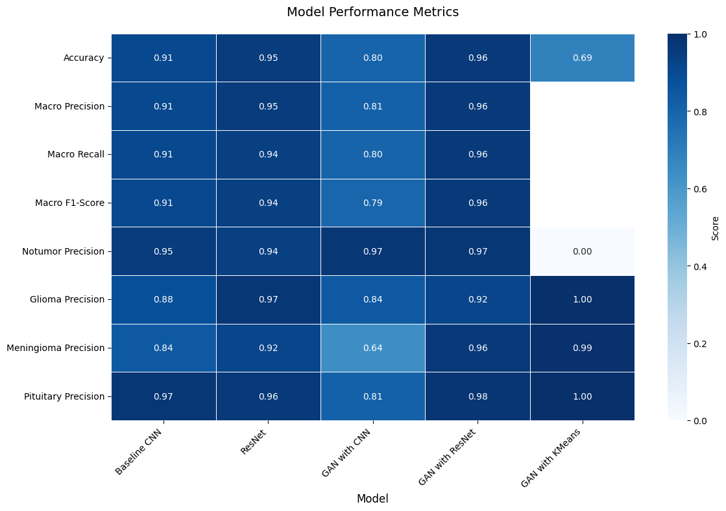
Heatmap of Performance Metrics of Various Models

Accuracy and Performance:
- The GAN with ResNet Classifier model provided the highest accuracy at 97%. This model was extremely consistent performance across all metrics.
- The Baseline CNN showed respectable performance with 91% accuracy, but slightly lagged in handling the "meningioma" and "glioma" tumour classes.
- The traditional ResNet model performed better than CNN (95%) due to its deeper architecture and residual connections.
- The GAN with CNN classifier underperformed in comparison, particularly for "meningioma" detection. The significant drop in Meningioma precision suggests potential difficulties in generating realistic features for this specific tumour type.
- GAN with unsupervised KMeans classifier had a moderate tumour detection accuracy (69.03%), with outstanding results in detecting "glioma," "meningioma," and "pituitary," but significantly struggled with detecting "notumor."

Reasoning About Hyperparameters:
- Learning Rate: Throughout the training process, learning rate tuning proved essential. A lower learning rate (0.0001) was used for deep architectures like ResNet and the GAN-based models to avoid overfitting and improve convergence. For the baseline CNN, a slightly higher learning rate (0.001) worked well in speeding up the training without compromising the accuracy.
- Batch Size: Larger batch sizes (64-128) were employed for ResNet models to allow faster training with stable gradients, whereas smaller batch sizes (32) were used for GAN models to maintain generator-discriminator balance during training.
- GAN Anomaly Threshold: In GAN-based models, the anomaly threshold was carefully adjusted. A higher threshold would classify more images as normal, which hurt recall, while a lower threshold captured more anomalies but led to a higher false positive rate.
- Regularization: L2 regularization and dropout were applied to the CNN and ResNet models to mitigate overfitting. A dropout rate of 0.5 in dense layers balanced generalization and performance in these models.
- Architecture Adjustments: For the CNN and hybrid models, the number of convolutional layers and filter sizes were iteratively tuned based on validation performance.

Brain Tumour Classification Model Analysis
Baseline CNN Model
Overall Accuracy: 91%
Key Strengths:
- Excellent performance on notumor (96% F1-score) and pituitary cases (96% F1-score)
- Consistently high precision and recall across classes
Areas of Challenge:
- Lower performance on glioma (88% F1-score) and meningioma (84% F1-score)
Analysis: The baseline CNN provides solid foundational performance, particularly strong in distinguishing normal tissue and pituitary tumours. The slightly lower performance on glioma and meningioma suggests these classes have more subtle distinguishing features.

ResNet Model
Overall Accuracy: 95%
Key Strengths:
- Superior performance across all metrics compared to baseline CNN
- Exceptional notumor detection (96% F1-score)
- Outstanding pituitary tumour classification (98% F1-score)
- Strong glioma detection (95% F1-score)
Areas of Challenge:
- Slightly lower performance on meningioma (88% F1-score), though still strong
Analysis: ResNet's deeper architecture clearly provides better feature extraction, resulting in improved classification across all tumour types. The high recall (99%) for notumor cases is particularly noteworthy for screening applications.

GAN with CNN Classifier
Overall Accuracy: 80%
Key Strengths:
- Strong notumor detection (89% F1-score)
- Good pituitary tumour detection (88% F1-score)
Areas of Challenge:
- Poor glioma recall (57%)
- Inconsistent meningioma classification (74% F1-score)
Analysis: The GAN-CNN combination shows significant performance degradation compared to pure CNN approaches. The model struggles particularly with glioma detection, suggesting the GAN-generated features might not effectively capture the subtle characteristics of this tumour type.

GAN with ResNet Classifier
Overall Accuracy: 97%
Key Strengths:
- Exceptional performance across all metrics
- Near-perfect pituitary classification (99% F1-score)
- Excellent meningioma detection (97% F1-score)
- Strong glioma classification (92% F1-score)
Analysis: This combination achieves the best overall performance, suggesting the ResNet architecture effectively leverages the GAN-generated features for classification. The high consistency across all classes indicates robust feature extraction and classification capabilities.

GAN with Unsupervised KMeans Classifier
Overall Accuracy: 69.03% (tumour detection), 52.65% (tumour classification)
Key Strengths:
- Near-perfect detection of glioma, meningioma, and pituitary tumours (99-100%)
Critical Weakness:
- Extremely poor notumor detection (0.25% accuracy)

Analysis: The unsupervised approach shows significant limitations, particularly in distinguishing normal tissue from tumours. While it can detect specific tumour types well, the extremely low performance on normal tissue makes this approach impractical for clinical applications.

Insights from UnsupervisedKMeansClassifier Failure
- The KMeans classifier performs poorly, especially for the 'notumor' category, which only has a 0.25% detection accuracy. This happens because KMeans cannot form distinct clusters for this class.
- This because of lack of Label Supervision, KMeans doesn’t have label supervision, so it purely relies on feature distance to create clusters. If the feature space is not well separated between tumour and non-tumour cases, KMeans will misclassify them.
- Imbalanced Clusters: KMeans tends to form clusters of similar size, and if one class (e.g., tumours) dominates, it could force non-tumour images into a misclassified cluster.
- Only a simple unsupervised was made as the computational time for choosing appropriate thresholds while processing large amounts of images was very high.

15. Conclusion

This project aimed to explore both supervised and unsupervised approaches for brain tumour detection, combining GAN-based anomaly detection with classifiers. We implemented a GAN model to generate normal brain MRI images, intending to detect anomalies associated with tumours. While the GAN approach showed promise for anomaly detection, particularly in handling axial view images, the unsupervised models based solely on the generator and discriminator did not yield satisfactory results.
The results of hybrid model, using GAN with Supervised Classifiers did yield slightly better results but, these are not good enough especially in the case medical imaging. One of the main reasons for this the GAN model being trained only on the axial MRIs. The computational cost and time required to train GAN model on different orientations of MRIs i.e. axial, sagittal, coronal is very high. Addressing multi-view image classification is an area for future improvement.
Both the CNN and ResNet models demonstrated strong performance in brain tumour detection. Their success can be attributed to several key factors. The basic CNN, with its straightforward architecture, excelled at extracting essential features from MRI images, capturing patterns associated with tumour characteristics. Its simplicity allowed for efficient training while maintaining a good balance between model complexity and generalization. The ResNet model, on the other hand, performed exceptionally well due to its deeper architecture and the introduction of residual connections
Overall, this project provides good insights and solid foundation into GAN based anomaly detection for brain tumour detection, combining anomaly detection with classifiers. Further enhancements could involve training models on all three MRI views, optimizing the unsupervised models to better capture tumour-specific anomalies and process the anomaly thresholds much faster and reduce the computational times.

GAN Model Outputs and Anomaly Detection Visualisation
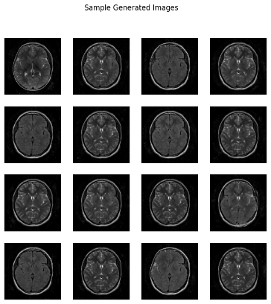 | 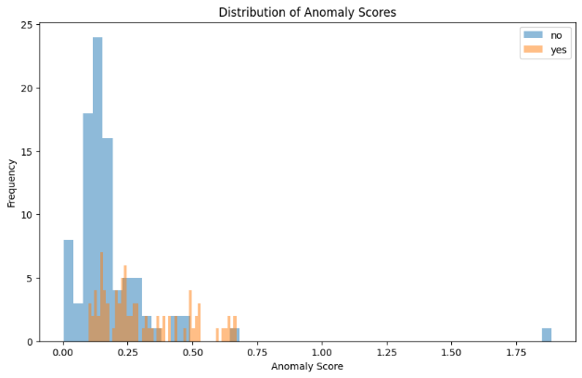
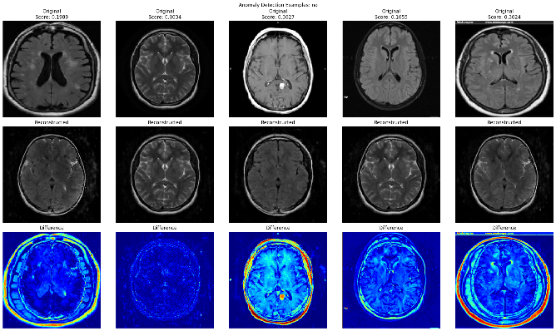 | 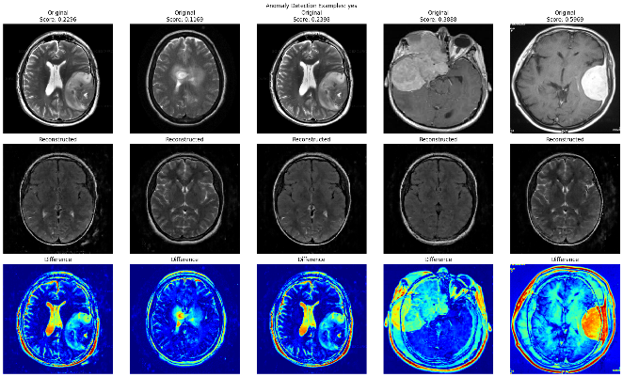

Baseline CNN
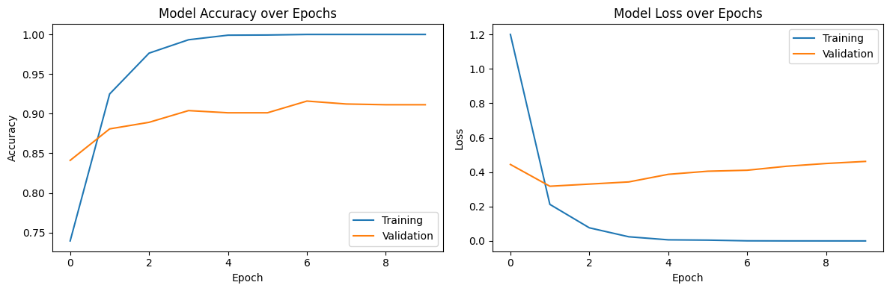

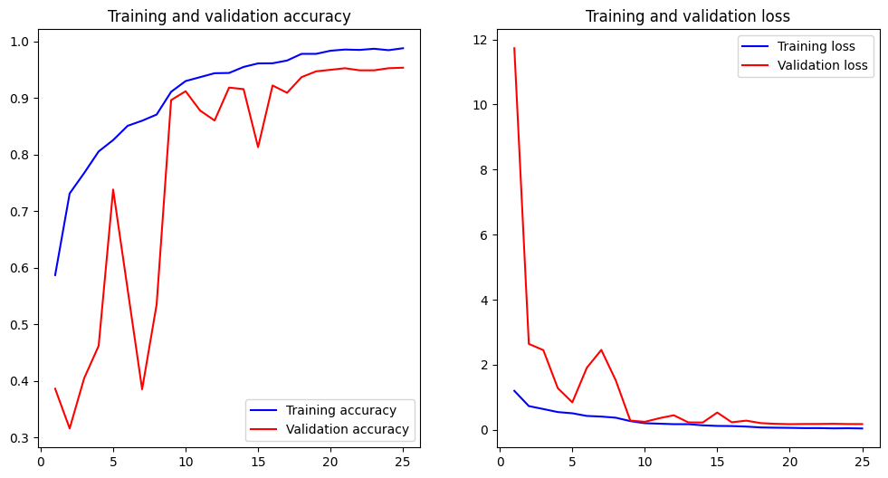
ResNet

GAN with CNN Classifier
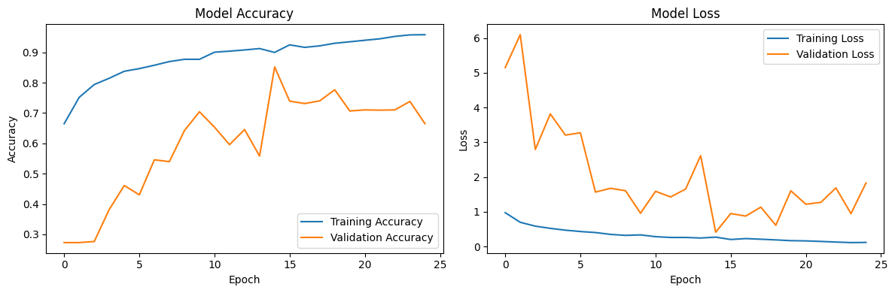

GAN with ResNet Classifier
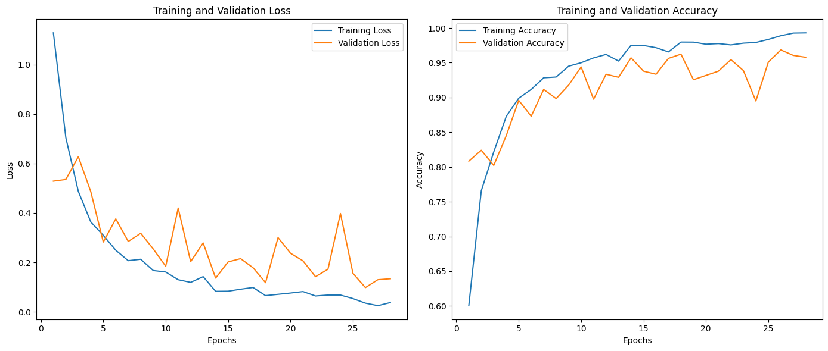

Deployment On HuggingFace

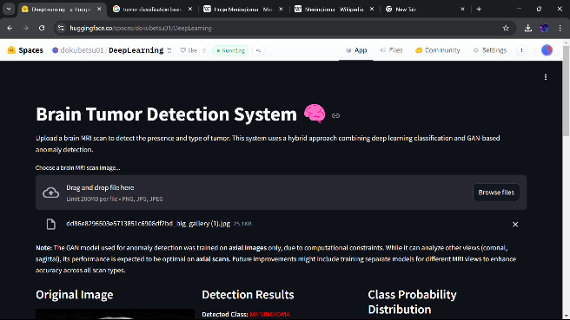 | 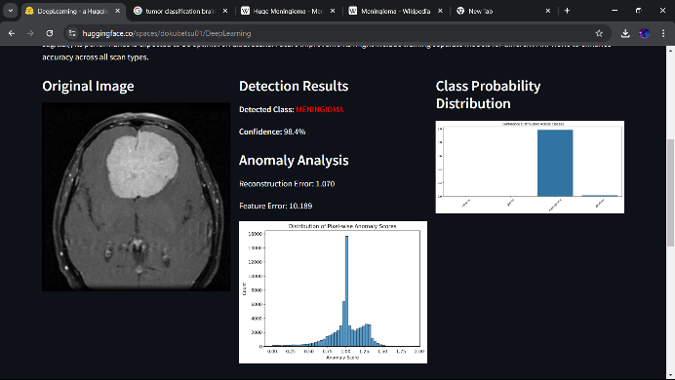
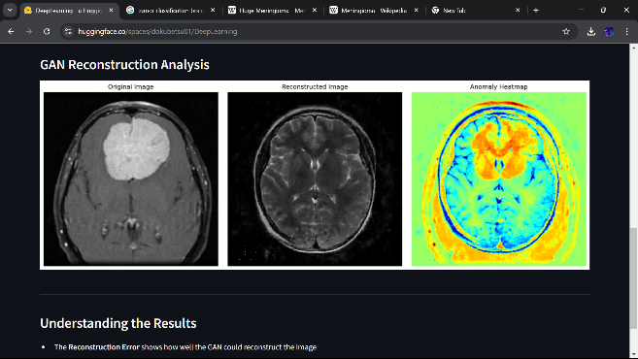 | 